**You and your child are invited**

**to an afternoon of fun activities**

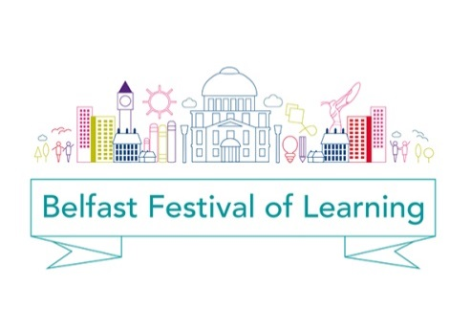

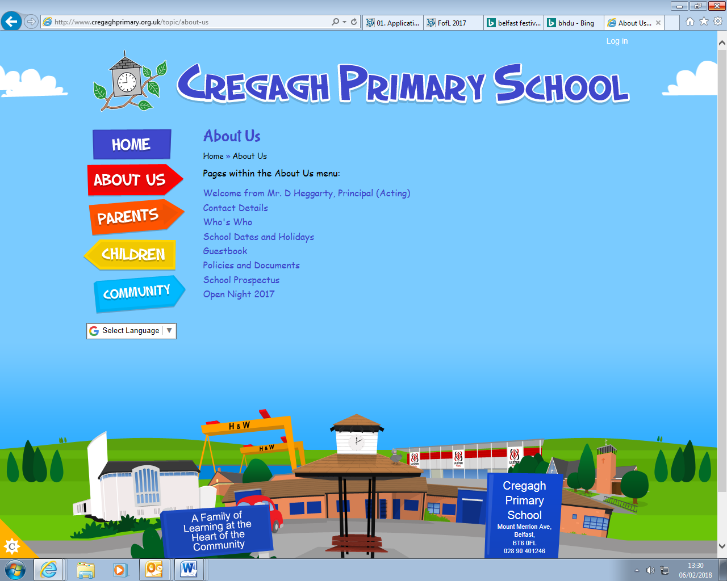

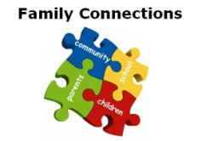

**by Family Connections**

**in Cregagh Primary School**

**-part of the Festival of Learning**

**Thursday 8th March**

**2 – 4pm**

**Cregagh Primary School Hall**

**(BT6 0FL Belfast)**

**Activities for children aged 0-11 and their parents.**

**Complete your Passport to Learning for a prize.**

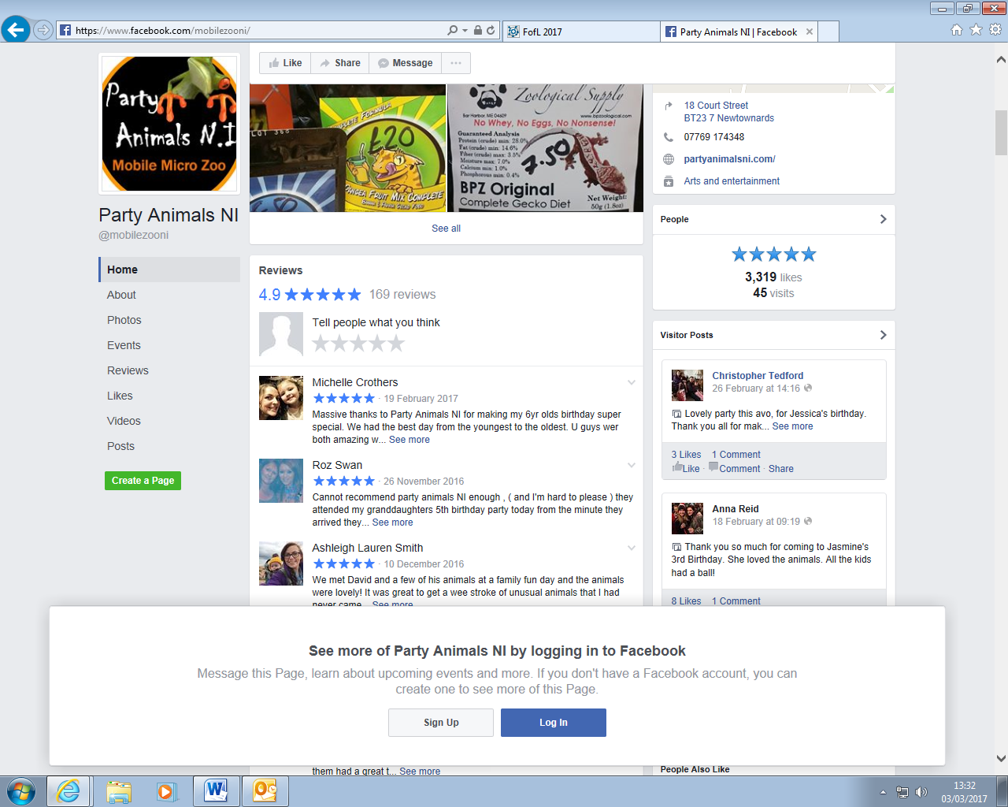

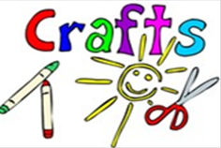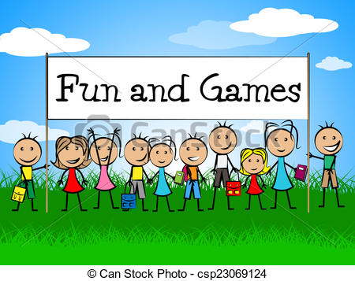

**Snacks, community information and more for free!!**

**For more information please contact Roz on 07720337117**

**All children**

**must be accompanied by an adult.**

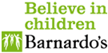

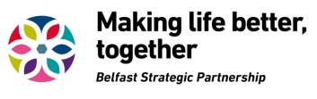

**You and your children are invited**

**to an afternoon of fun activities**





**by Family Connections**

**in Cregagh Primary School**

**-part of the Festival of Learning**

**Thursday 8th March**

**2 – 4pm**

**Cregagh Primary School Hall**

**(BT6 0FL Belfast)**

**Activities for children aged 0-11 and their parents.**

**Complete your Passport to Learning for a prize.**





**Snacks, community information and more for free!!**

**For more information please contact Roz on 07720337117**

**All children**

**must be accompanied by an adult.**

