‘Achieving Excellence Together’
Attendance Matters! – Monthly attendance letter
www.eani.org.uk/schools/miss-school-miss-out/

_________________________________________________________
Request to leave school early

We appreciate that it is necessary for pupils to leave school early on occasions for family matters or appointments.
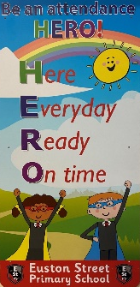
The school try to be as supportive as is best possible.
Parents should be mindful that too many occasions will impact on
their child’s learning and then progress.
Too many requests may also require the school to monitor overall attendance.
If you have any concerns or questions, please contact the school 02890457089.

‘Achieving Excellence Together’
Attendance Matters! – Monthly attendance letter
www.eani.org.uk/schools/miss-school-miss-out/

_________________________________________________________
Request to leave school early

We appreciate that it is necessary for pupils to leave school early on occasions for family matters or appointments.
The school try to be as supportive as is best possible.
Parents should be mindful that too many occasions will impact on
their child’s learning and then progress.
Too many requests may also require the school to monitor overall attendance.
If you have any concerns or questions, please contact the school 02890457089.

