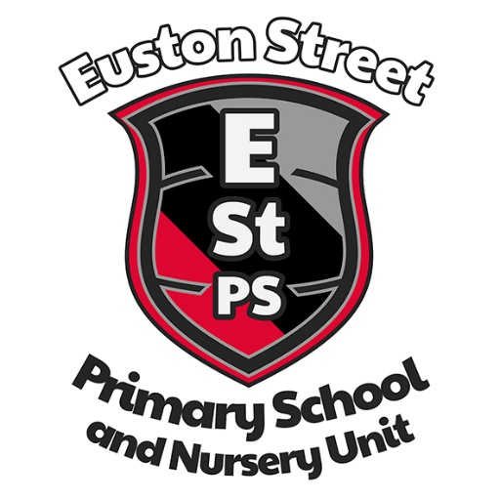

Euston Street P.S.
& Nursery Unit

Meals & Milk Policy (Draft)

Commitment to review
Date the plan came into effect | December 2017
Who is responsible for this document | Principal, SLT, SMT, staff, BoG
Issued to | Staff, BOG, parents,
Date of issue | December 2017
Review date | December 2019  Reviewed September 2020

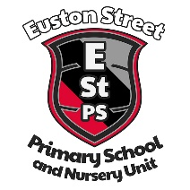
Euston Street Primary School & Nursery Unit

Meals & Milk Policy

Purpose
Mission
‘To work together for excellence in: our learning; our school; our community; and our future’.
Our purpose therefore is to be an excellent school. We continually strive for excellence in every area of school life. To achieve this aim we must always have the right school vision and values and these must be at the heart of all that we do, including our School Development Plan.
Vision
In order to achieve excellence in each aspect of school life, our vision is:
'To create a safe, happy learning community. A community where together, we inspire and equip our pupils so that they fulfil their potential, use their talents and follow their dreams now and always.’
Values
We believe that our school is a place where the child is at the centre.
‘We value kindness, integrity, hard work and mutual respect.'

Introduction
The purpose of this policy, as with all of our policies, is to support us as we strive for excellence in every area of school life. To achieve this, we must always have the right school vision and values and these must be at the heart of all that we do, including our engagement with parents and guardians.

This policy outlines the procedures for pupils receiving school meals in school.

The Board of Governors, Senior Leadership Team and teaching staff of Euston Street Primary School recognise that a healthy balanced diet is an important factor in the daily routine of pupils. In Euston Street Primary School & Nursery Unit, we work to ensure that pupils are provided with their school meal & milk on time and as requested. As a school we work tirelessly to make payment and information access as easy as possible for parents/guardians. The school office and teachers process payments. The school meal & milk information is available on the school website from the school office as a paper copy for the month.

School Milk
Parents may pay for milk in school. The pupils will receive the milk at break time in school. All school milk should be paid for in advance please ensure that you provide the exact amount as, for security reasons, the school office holds only a limited amount of change. All payments should be made via SchoolMoney (Eduspot) details of which are given to new parents and are available from the school office and website. The school will not be able to provide milk to any child without prior payment.

School Milk Prices (subject to annual change by E.A.)

19p per day, 95p per week

Free School Meals
Pupils whose parents/guardians are in receipt of particular support payments and meet certain criteria may be eligible to receive free school meals. If you believe that you may be eligible for free school meals, please contact our receptionist in the school office for details and application form. Your query will be handled in the strictest confidence. (Or contact the EA Belfast Region Students Awards sections directly) – more information can be obtained via www.eani.org.uk or phone 02890564000.

School Meal Prices (subject to annual change by E.A.)

Nursery Unit
£2.50 per day, £12.50 per week

Primary School
£2.60 per day, £13.00 per week

Meal Requests

If a parent requests a specific meal for their child with regards to documented dietary requirements or religious reasons, then they should contact the school office to complete a dietary request form. All requests for changes to a child’s provision must also have a letter form the child’s GP confirming such a request. The Education Authority will not now provide changes to dietary requests without a letter from the GP.

Payment

All school dinners should be paid for in advance. All payments should be made via SchoolMoney (Eduspot) details of which are given to new parents and are available from the school office and website. The school will not be able to provide meal to any child without prior payment.

Late Payment procedure

Please note that the school is unable to supply dinners to any pupils who owe dinner money. This is because the school is responsible for any debts incurred, and any shortfall in school dinner revenue has to be taken from school funds.

Stage 1
If a parent incurs debts for unpaid dinner money, the school will telephone the parent/guardian after one week’s debts have accumulated. This phonecall will ask the parent/guardian to pay the debt by a specified date (usually within 1 week).

Stage 2
If the parent/guardian does not pay the debt by the specified date, a letter will be sent after two weeks’ debts have accumulated. This letter will ask parent/guardian to pay the debt by a specified date (usually within 1 week) or their child will be refused a school dinner from that point onwards.
Should the debt not be paid and the pupil has had no obvious suitable lunch provided, the school Principal (or delegated senior member of staff or school secretary) will phone the parent/guardian and ask them to either:
- bring the money before dinner time or;
- bring sandwiches to school before dinner time or;
- collect their child and take them home for lunch.

Stage 3
If the parent/guardian does not pay the debt by the specified date, a second letter will be sent if the debt has not been cleared. This letter will ask parent/guardian to pay the debt by a specified date (usually within 1 week) or the school will send a final letter.

Stage 4
If the parent/s does not comply with stages 1 - 3, the Principal will send a
final letter explaining that the school will ask the Education Authority to begin legal proceedings against the parent/guardian to recover the debt and costs.

As a school we work with all parents/guardians to help ensure that any outstanding debt is sorted quickly to try and stop the need for more formal proceedings.

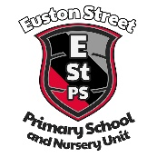
Child’s Name
Unpaid Dinner Money
First Letter

Dear
As you know we have a protocol for unpaid dinner money. I am enclosing a copy.
You now owe us £ for dinner money for days.
Please can you pay us this debt by .

Yours sincerely
John Armstrong

Principal

Date
Child’s Name
Unpaid Dinner Money
Second letter

Dear
We wrote to you previously asking you to pay the debt for school dinners. As you know we have a protocol for unpaid dinner money. I enclosed a copy with the first letter.
We have not yet received this payment and you now owe us a total of £
If we do not receive the money by we will be unable to continue to provide a school dinner due to costs and you will have to provide a packed lunch or take your child home for dinner.
Please can you pay us this debt by the above date.

Yours sincerely
John Armstrong

Principal

Date
Child’s Name
Unpaid Dinner Money
Final letter

Dear
The school have telephoned and written to you on 2 previous occasions about unpaid dinner money. You still owe the school £
Please send this money to school by and we will then be able to continue to provide school dinners for your child. Thank you in advance of payment.
If we do not receive this money by the above date, we will unfortunately have no other option but to ask the Education Authority to begin legal proceedings against you to recover the debt and costs.

Yours sincerely
John Armstrong

Principal

