**Euston Street School Council Trip to Stormont**

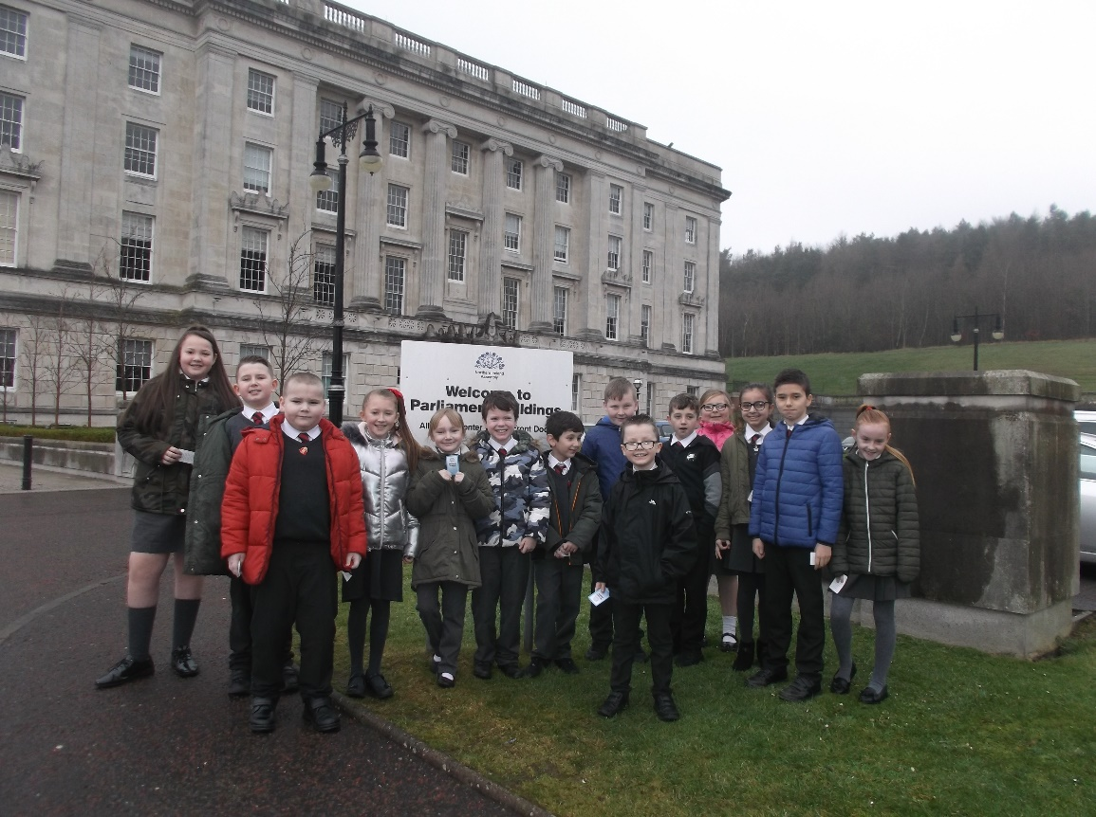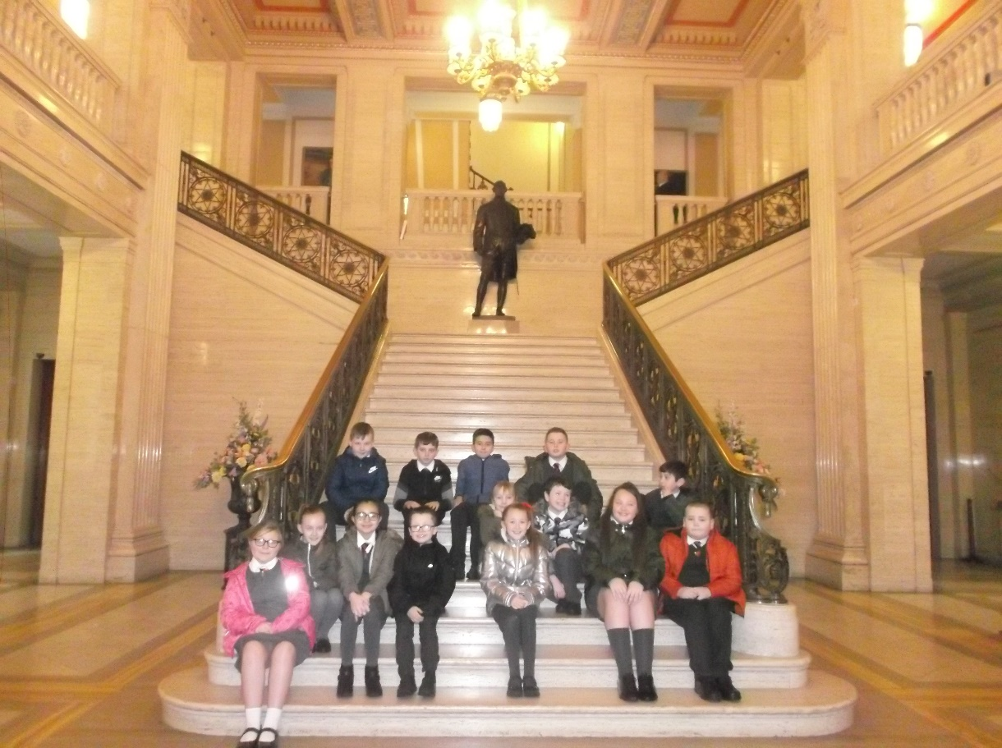

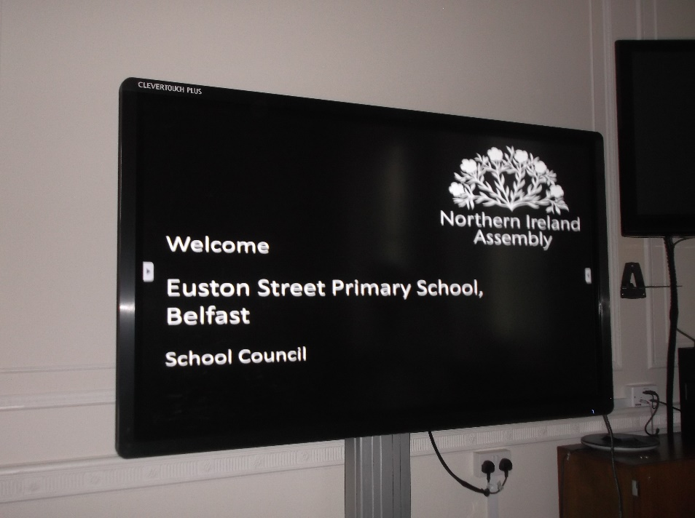

On Thursday 28th February 2019 our School Council went on a visit to Stormont Parliament Building. We compared our roles and responsibilities with those of our MLA’s.

We enjoyed a tour of the building and found out many facts about the assembly, the voting system and what MLA’s should be doing for Northern Ireland!

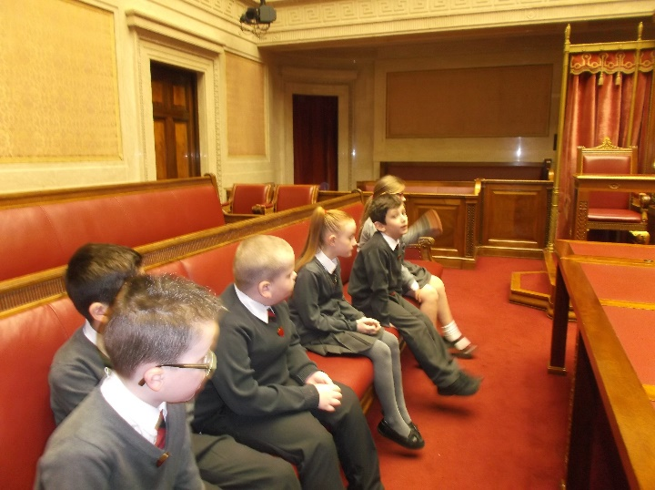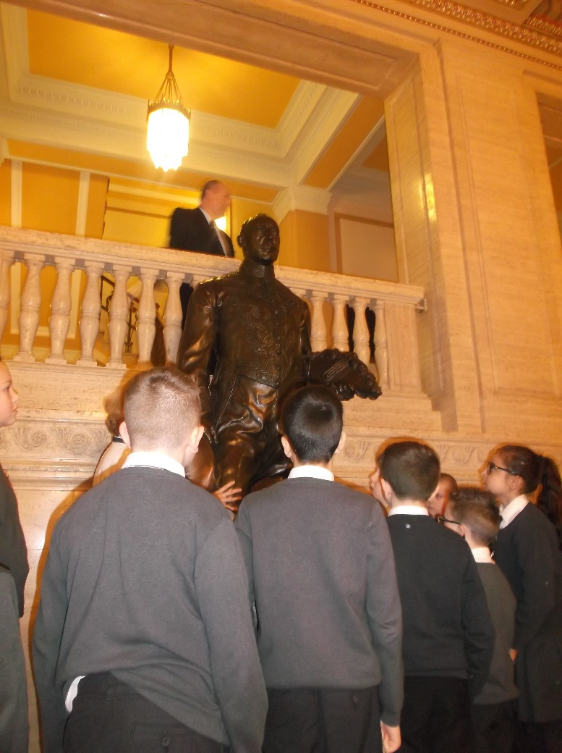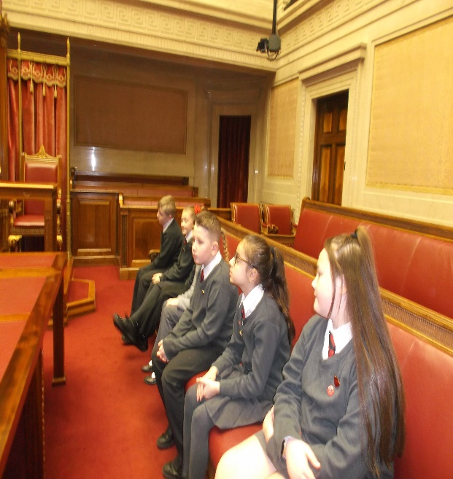

James Craig, a life-size a statue of the first Prime Minister of NI.

Inside the Senate Chamber. This room is used as a committee room. We found out, this room was used as an operations rooms by the Royal Air Force during the WW2.

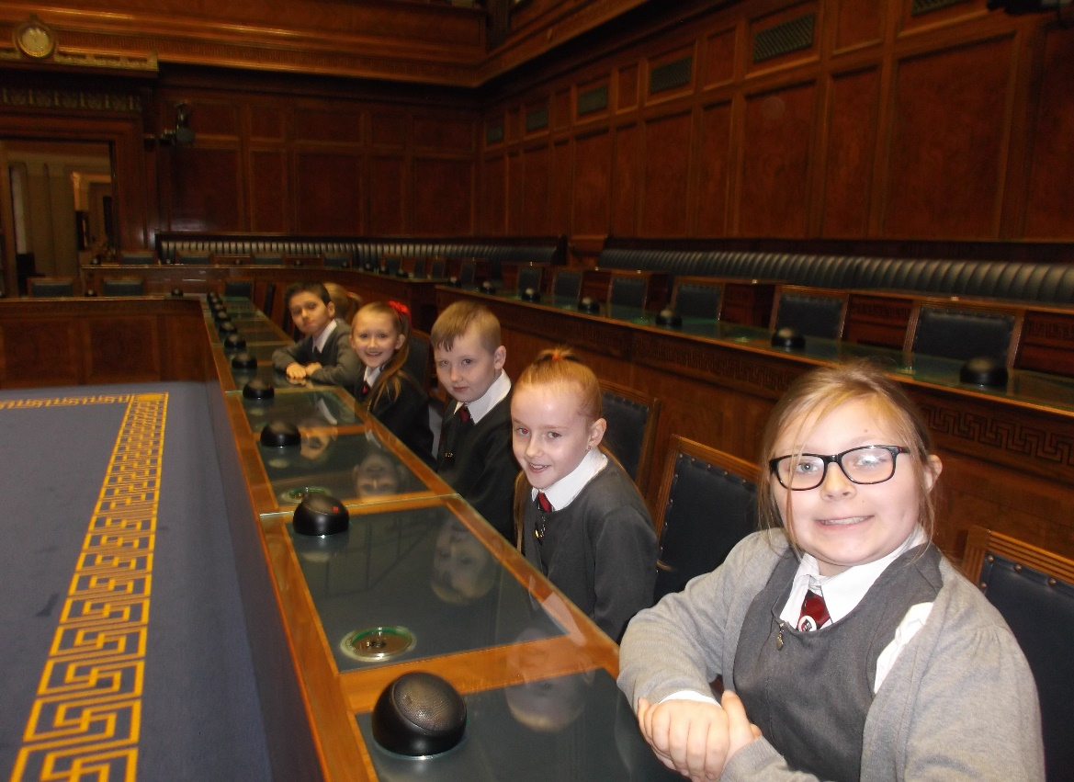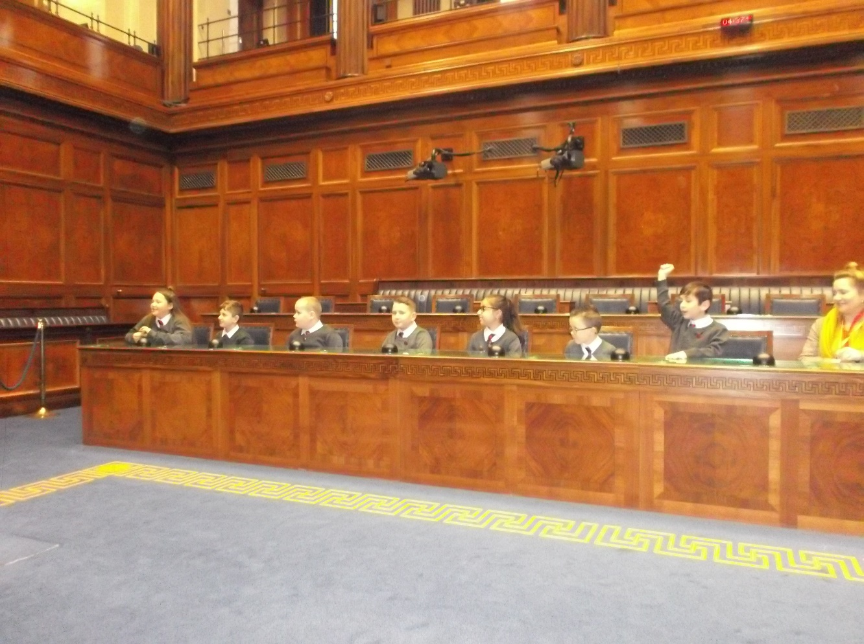

We also sat in the Assembly chamber. We found out about the role of the speaker and sat in the First Minister and Deputy First Minister’s chairs.

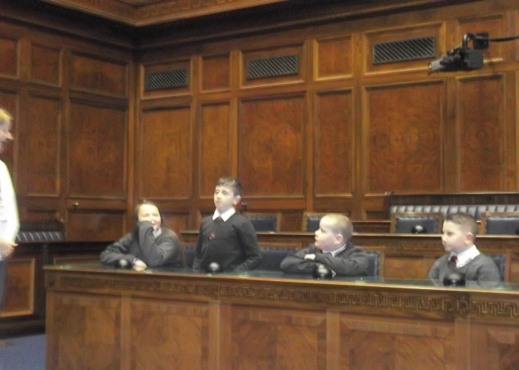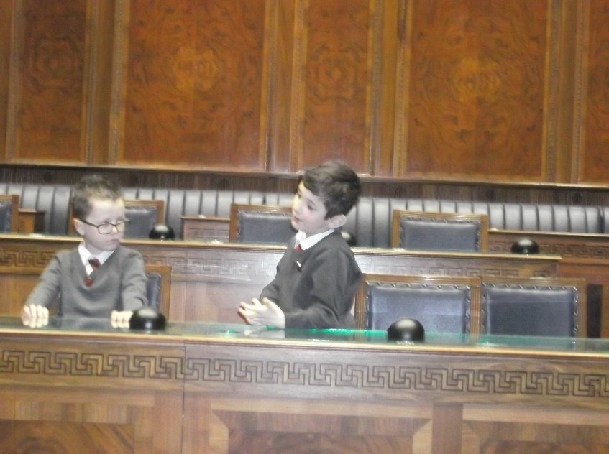

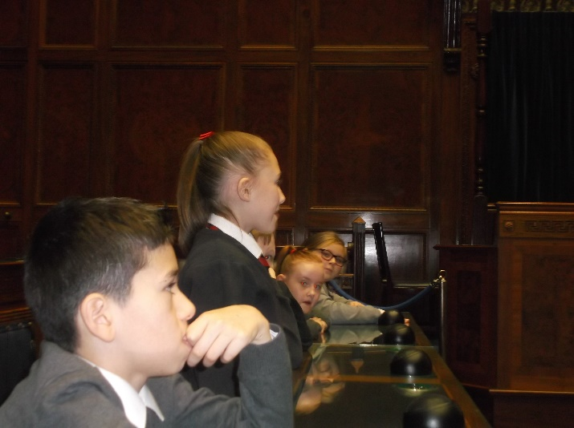

In the Assembly chamber we had a debate about school uniform. The proposal to ban school uniforms was argued by one party and the opposing party provided lots of ideas against banning school uniform. The speaker announced each person as they gave their opinions and their party agreed by shouting “hear hear” while the other party grumbled!

At the end of the debate each member voted to pass or reject the new legislation. We went through a voting door leading into a corridor and back to the chamber.

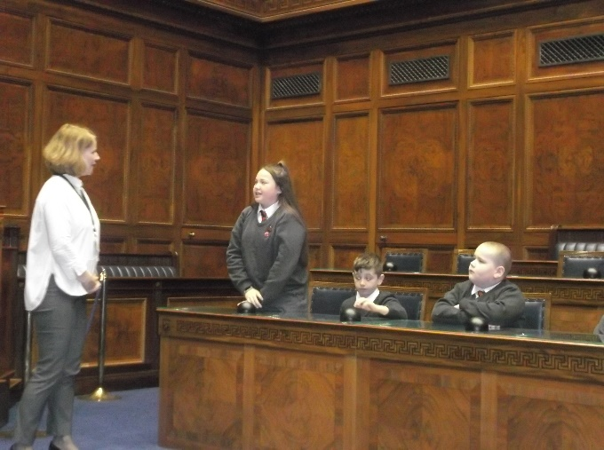

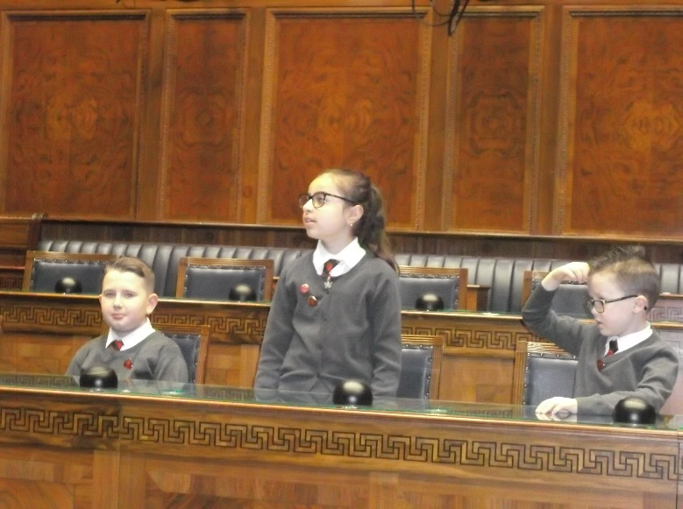

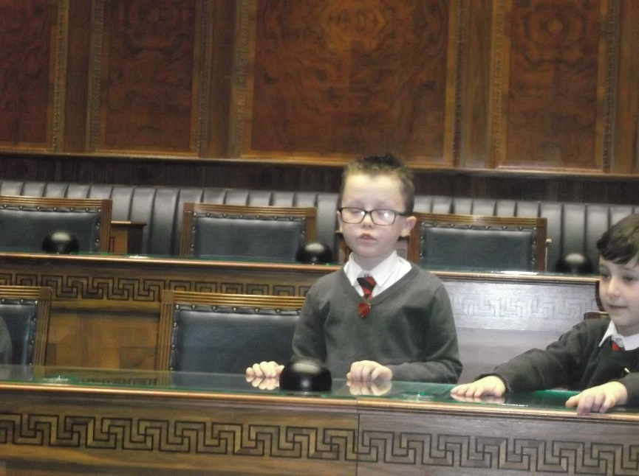

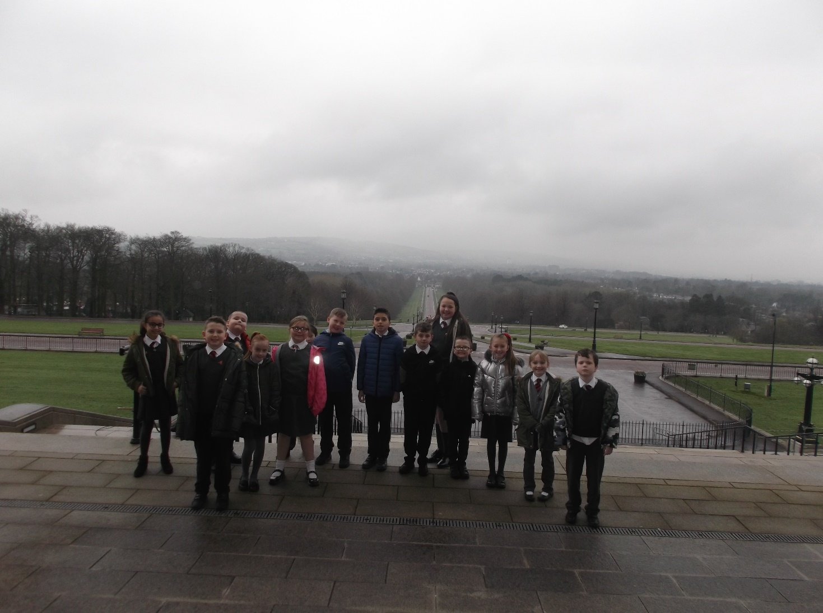

The school council had a great trip. We learnt lots of new information about the NI Assembly, enjoyed playing our part in Parliament and this inspired a few school council members to get more involved with local politics!

Mr Armstrong even treated us to a lunch treat for all our hard work to date in our School Council role.

